EXPERIMENT – 2
PANDAS LIBRARY – BASIC CONCEPT
Aim:
To upload and analyze dataset given in csv format and perform data preprocessing and visualization
Procedure:
- Upload the csv file and read it
- Import the necessities like pandas ,numpy and seaborn
- Now visualize bar plot for sales over products , line plot for sales over time and correlation matrix

Program:
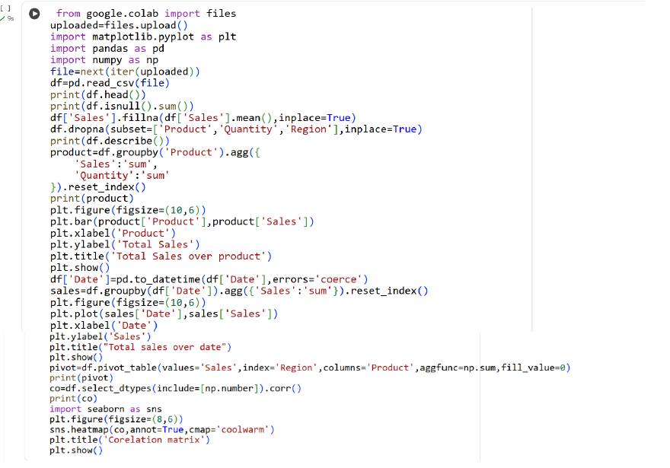

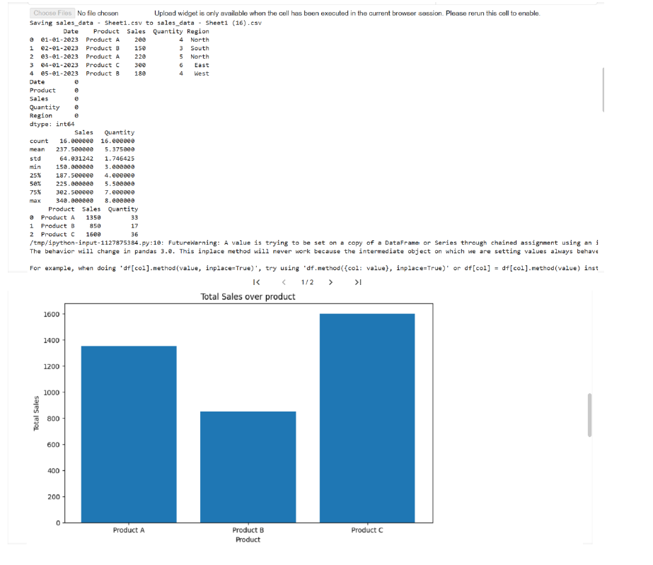
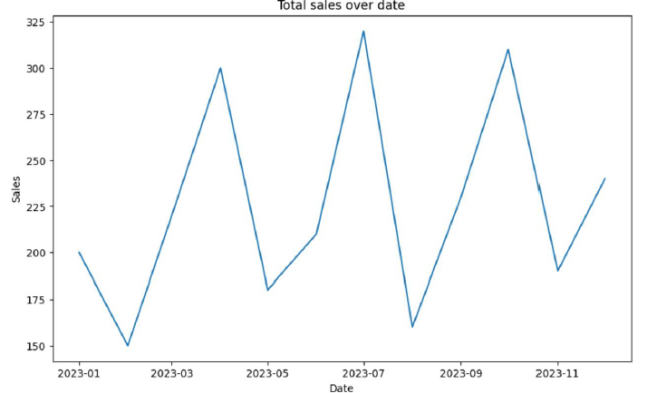

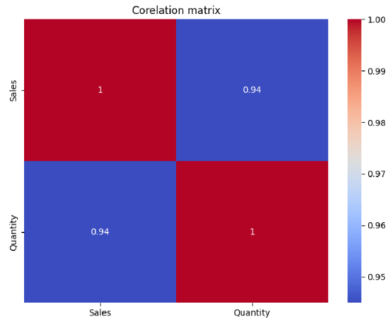
Result:
Thus the python program to analyze the given dataset and perform data processing is executed and verified

